Clustering-Based Weather Forecasting Analysis: Task Sheet

1. Data Understanding and Exploration
Question: What are the key characteristics and variables of the weather dataset, and what insights can we initially extract?
Focus Areas: Data shape, data types, feature overview, summary statistics, initial patterns, and presence of missing values.
Answer:
- The data is of the shape (679, 13).
- All variables apart from date (which is in object format) are in number format (int/float). We will need to change the date to datetime format.
- Based on data overview and summary, we can see that there are no null values and the data is for 679 unique dates. The statistical summaries can be seen in the table below.
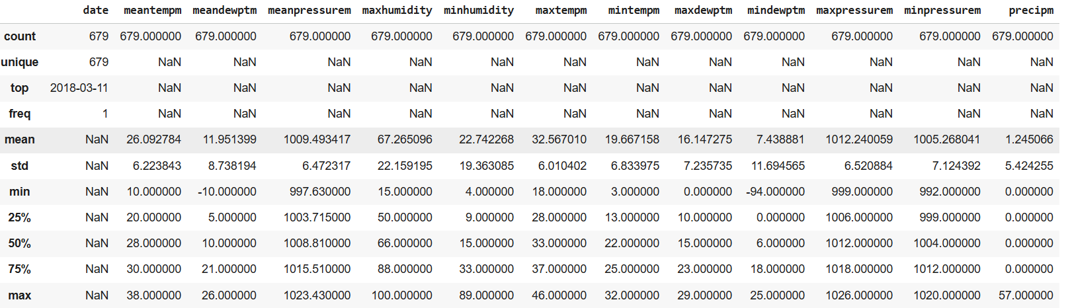

2. Data Cleaning and Preparation
Question: What data quality issues are present in the dataset, and how should they be addressed effectively?
Focus Areas: Missing values handling, date formatting and parsing, duplicate records, consistency checks.
Answer:
- There are no missing values, or duplicates in the data.
- The date was converted from object to datetime format. We sorted the dataframe with respect to this date and made it the index.
- Data consistency will be checked more appropriately during EDA

3. Exploratory Data Analysis (EDA)
Question: What patterns, relationships, and distributions do the weather attributes exhibit?
Focus Areas: Distribution plots, correlation heatmaps, pairplots, outlier detection, visual interpretation.
Answer:
Univariate analysis based on KDE plots and box plots:
Feature Name | Description
date | Date of the weather observation. In sequence and unique.
meantempm | 2 peaks in KDE, no major outliers
meandewptm | 2 peaks in KDE,no major outliers
meanpressurem | 2 peaks in KDE,no major outliers
maxhumidity | 2 peaks in KDE,no major outliers
minhumidity | 1 peak in KDE, outliers are present.
maxtempm | 1 peak in KDE, no major outliers
mintempm | 2 peaks in KDE, outliers are present.
maxdewptm | 2 peaks in KDE,no major outliers
mindewptm | 2 peaks in KDE,no major outliers
maxpressurem | 2 peaks in KDE,no major outliers
minpressurem | 2 peaks in KDE,no major outliers
precipm | 1 peak and a lot of outliers are present.

Bivariate analysis using pairplot, and heatmap among weather attributes:
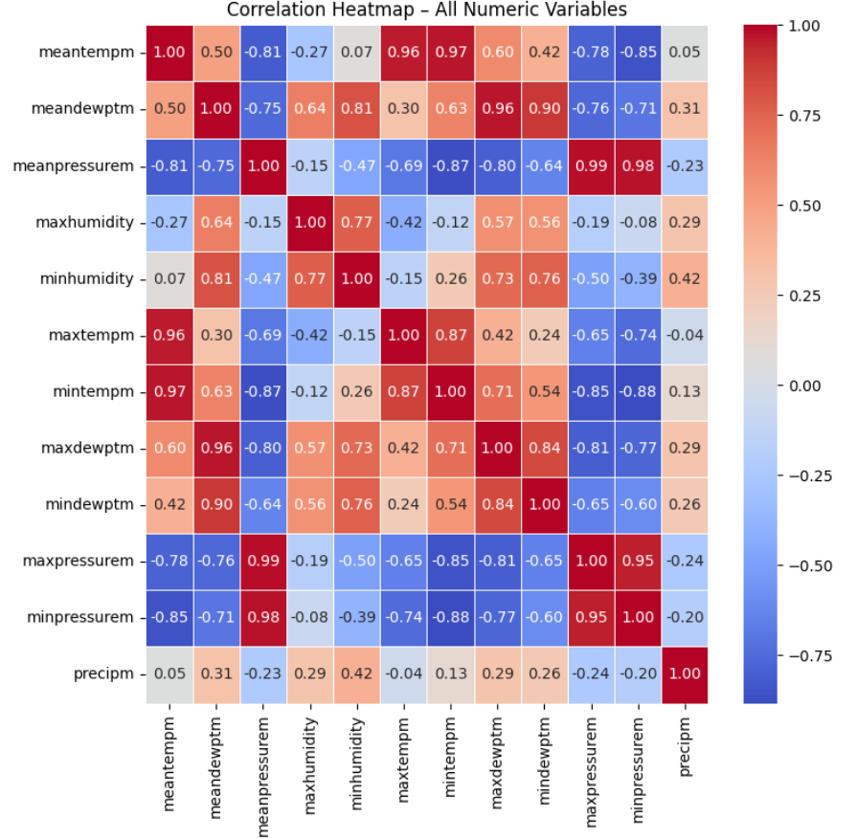
Some relationships here are obvious as they reflect the same quantity (example: mean pressure, max pressure and min pressure are highly correlated, or max min and mean temperatures are related, or max min and mean dew points are related as well.)
Actual meaningful correlations are the following:
- Pressure and temperature correlation is strongly negative (–0.70 to –0.87)
- Min temperature and dew point correlation is highly positive (0.63–0.84).
- max temperature and humidity correlation is moderately negative (–0.12 to –0.42).
- Pressure and humidity correlation is moderately negative (–0.47 to –0.69).
- Precipitation and humidity correlation is weak-to-moderate positive (0.29–0.42).
We can observe similar trends in pairplot too. I am not posting it here because it will become very large.

4. Hypothesis Testing of Weather Variables
Question: Can we validate significant relationships between temperature and other weather variables, such as humidity and pressure?
Focus Areas: Hypothesis formulation, correlation tests, statistical significance, practical interpretation.
Answer:
We used pearsonr correlation from scipy with significance level of 0.05, and established all these relationships are statistically significant, confirming that temperature does not behave independently and is influenced by pressure, humidity, and moisture levels.
- Temperature and pressure have a strong negative relationship, meaning hot days usually come with lower pressure.
- Temperature and humidity also move in opposite directions, so when the temperature rises, the air tends to feel drier.
- Minimum temperature and dew point show a strong positive link, which means nights stay warmer when there is more moisture in the air.
- We also found that pressure and humidity are weakly related, with higher-pressure days being slightly drier.
- Precipitation and humidity show a small positive relationship, which makes sense because higher humidity increases the chances of rain.

6. Feature Scaling for Clustering
Question: Why and how should we standardize weather data before applying clustering methods?
Focus Areas: Scaling importance, StandardScaler, normalization techniques, clustering accuracy impact.
Answer:
We standardize weather data because clustering algorithms like K-Means, GMM, and DBSCAN use distance, and unscaled features (e.g., pressure ~1000 vs. temp ~30) would dominate the results.Overall, scaling improves cluster separation, shape, and accuracy by preventing biased distance calculations.
Using StandardScaler (mean=0, std=1) puts all features on the same scale, ensuring fair contribution from temperature, humidity, pressure, and rainfall.
Normalization techniques like MinMaxScaler can also work but are less stable for UMAP/K-Means.
7. K-Means Clustering Application
Question: What weather patterns does K-Means clustering identify, and how do these clusters differ in weather characteristics?
Focus Areas: K-Means implementation, optimal clusters (Elbow method), cluster visualization (PCA/UMAP).
Answer:
K-Means clustering (k=4, chosen using the Elbow and Silhouette scores (0.464)) separated the weather data into four clear groups. The UMAP visualization showed good cluster separation, meaning the model picked up meaningful differences in temperature, humidity, pressure, dew point, and rainfall.
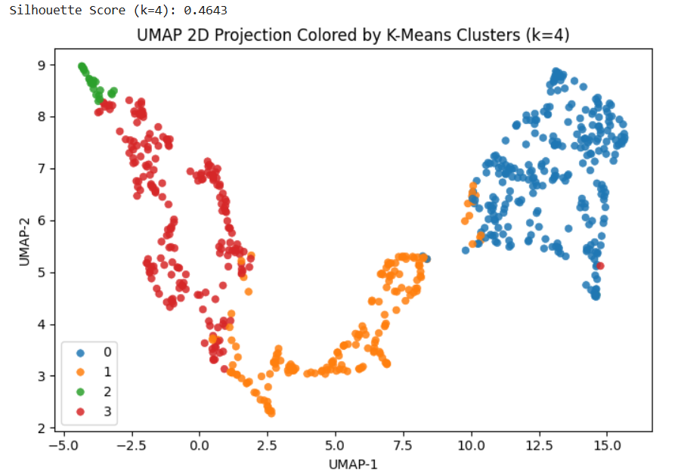
These clusters represent distinct weather patterns: cool and dry high-pressure days, hot and dry summer days, very humid heavy-rain monsoon days, and warm humid days with moderate rain. Overall, K-Means successfully captured the major seasonal and rainfall-driven regimes in the dataset.
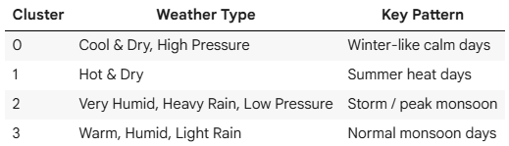

8. Gaussian Mixture Model (GMM) Clustering
Question: How do GMM clusters differ from those obtained by K-Means, and what additional insights do they provide?
Focus Areas: Probabilistic clustering logic, cluster overlap, visualization, interpretability.
Answer:
Gaussian Mixture Models (GMM) produced clusters that were very similar to K-Means but more flexible because GMM uses probabilistic clustering instead of hard assignments. While K-Means forces each point into exactly one cluster based on distance, GMM estimates how likely each point is to belong to each cluster, allowing it to handle overlapping or elliptical groups better. On the UMAP visualization, GMM showed smoother, softer boundaries between clusters, which is useful for weather data where transitions between dry, humid, and rainy days are gradual rather than sharp.
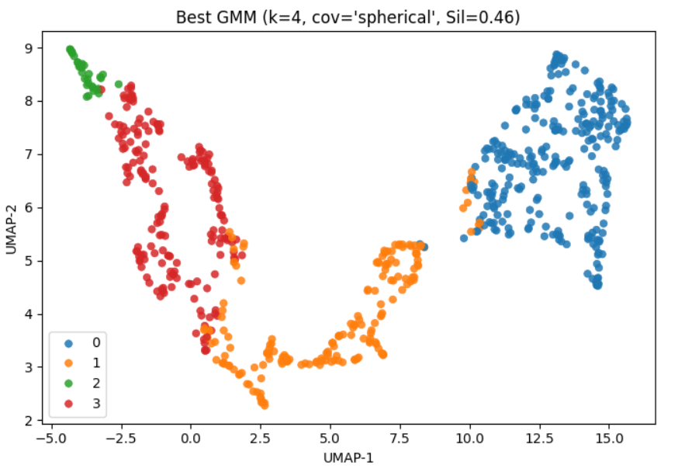
GMM also provided clearer insight into boundary or transitional weather days—for example, days that sit between “moderate rain” and “heavy rain” or between “hot dry” and “warm humid.” These points were forced into one group by K-Means but were recognized by GMM as having mixed characteristics. Overall, GMM adds interpretability by revealing uncertainty and overlap between regimes, while still recovering the same four major weather patterns: cool-dry days, hot-dry days, heavy-rain monsoon days, and humid monsoon days.
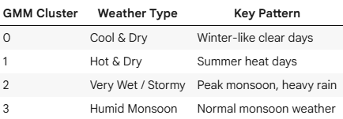

9. DBSCAN Clustering for Pattern and Outlier Detection
Question: Can DBSCAN effectively identify dense weather condition clusters and outliers within the dataset?
Focus Areas: Density-based clustering, tuning eps and min_samples parameters, outlier detection.
Answer:
DBSCAN did not produce useful clustering results for this weather dataset. Across the full grid search of eps and min_samples values, almost all combinations either labeled most points as noise or collapsed everything into one large cluster. The few runs that produced valid silhouette scores only did so by generating very large numbers of small clusters (often 20+ clusters), which is not meaningful for weather regimes. This happens because DBSCAN relies on sharp density boundaries, and the weather data forms continuous gradients rather than tight density pockets.
Since useful clusters require at least moderately dense and well-separated regions, DBSCAN struggled to identify any stable structure. Even in the rare cases where many tiny clusters appeared, they did not represent logical or interpretable weather patterns—they were just artifacts of over-segmentation. As a result, DBSCAN was not suitable for this dataset and failed to provide the clear seasonal or rainfall-driven groups that K-Means and GMM successfully captured.

10. Comparative Evaluation of Clustering Methods
Question: Which clustering method (K-Means, GMM, DBSCAN) provides the most meaningful interpretation of weather patterns and why?
Focus Areas: Cluster separation, interpretability, advantages, disadvantages, silhouette analysis.
Answer:
K-Means and GMM both produced clear, meaningful clusters with k=4 and a silhouette score around 0.46, capturing the same four weather patterns. Their UMAP plots showed strong separation, with GMM giving slightly softer boundaries but almost identical interpretations to K-Means.
DBSCAN didn’t work well—most settings produced either one big cluster, mostly noise, or 20+ tiny clusters that weren’t meaningful. DBSCAN couldn’t capture useful patterns, making K-Means and GMM the most reliable methods for this dataset.

5. Feature Engineering (Lag Features)
Question: What additional features derived from historical weather data can enhance forecasting accuracy?
Focus Areas: Lag features, rolling statistics, time-based feature extraction, feature relevance.
Answer:
To improve temperature forecasting, I engineered lag-based features that capture how today’s temperature depends on values from recent days. Specifically, I created lag1, lag2 and lag7.
These lags help the model understand short-term momentum and weekly patterns in the weather. After generating these features, I removed the initial missing rows and recreated the train–test split. Even though the ARIMA model itself does not use exogenous variables, these lag features prepare the dataset for stronger models like SARIMAX and help reveal how historical temperatures influence future values.

11. ARIMA Time-Series Forecasting
Question: How accurately can the ARIMA model forecast future mean temperature, and how reliable are the forecasts?
Focus Areas: ARIMA model fitting, forecasting accuracy, Mean Absolute Error (MAE), accuracy interpretation, residual analysis.
Answer:
The ARIMA(1,1,1) model was fitted on the training portion of the mean temperature series and used to forecast the full test window. The model achieved a Mean Absolute Error (MAE) of around 7.4°C and an overall forecast accuracy of roughly 63%, indicating that it captures the general trend but misses sharper changes in temperature. The forecast plot shows that ARIMA follows the broad direction of the test data but struggles with seasonal shifts and sudden rises or drops.
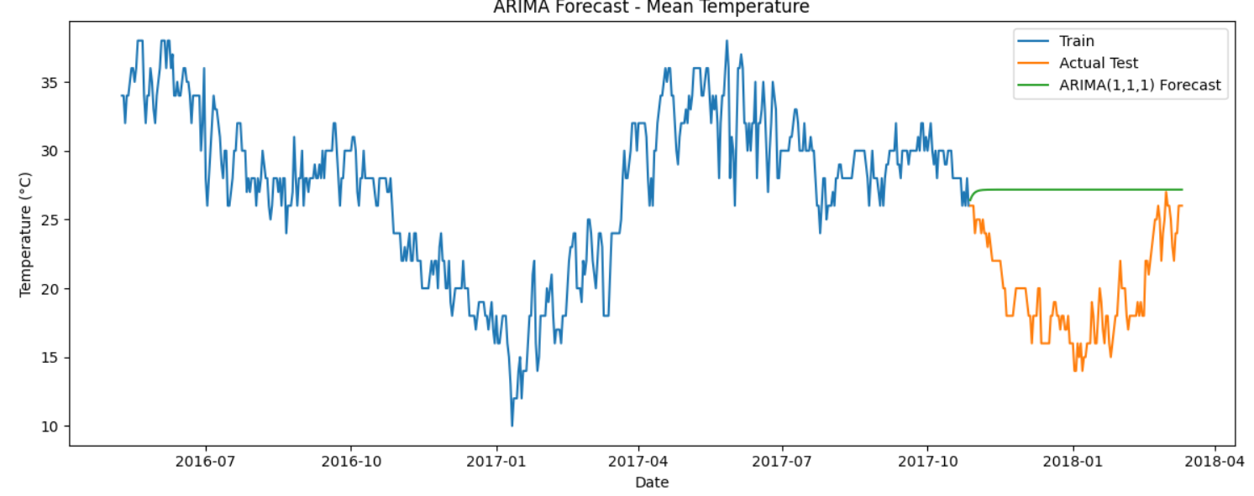
Residual analysis confirms this: the residuals show visible structure rather than pure noise, and the histogram is not centered tightly around zero. This means ARIMA leaves some autocorrelation unmodeled and is unable to fully track patterns driven by weather seasonality. Overall, ARIMA provides a reasonable baseline but is not highly reliable for daily temperature forecasting, especially when compared to more advanced models like SARIMAX.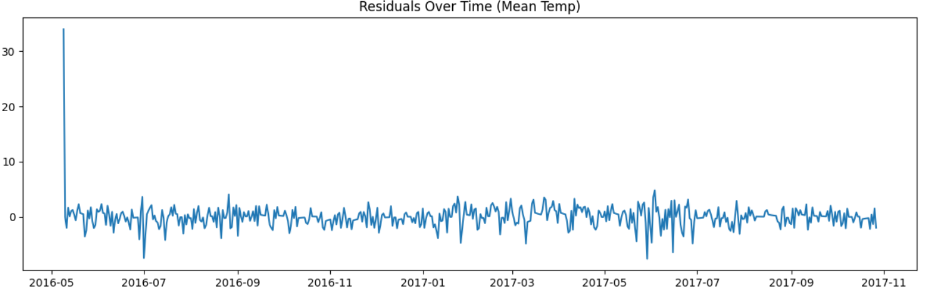

12. SARIMAX Time-Series Forecasting
Question: Does including seasonal components in the SARIMAX model significantly improve forecasting accuracy compared to ARIMA?
Focus Areas: Seasonal components, model performance comparison, MAE, accuracy metrics, forecast reliability.
Answer:
The SARIMAX model clearly outperformed ARIMA by incorporating monthly seasonality along with important weather drivers such as humidity, pressure, dew point, and precipitation and the lag terms as well. This combination reduced the MAE to 2.6°C and pushed accuracy close to 87%, compared to ARIMA’s 63%. The forecast tracked the test data more closely, especially around gradual warming and cooling phases where ARIMA tended to lag or overshoot.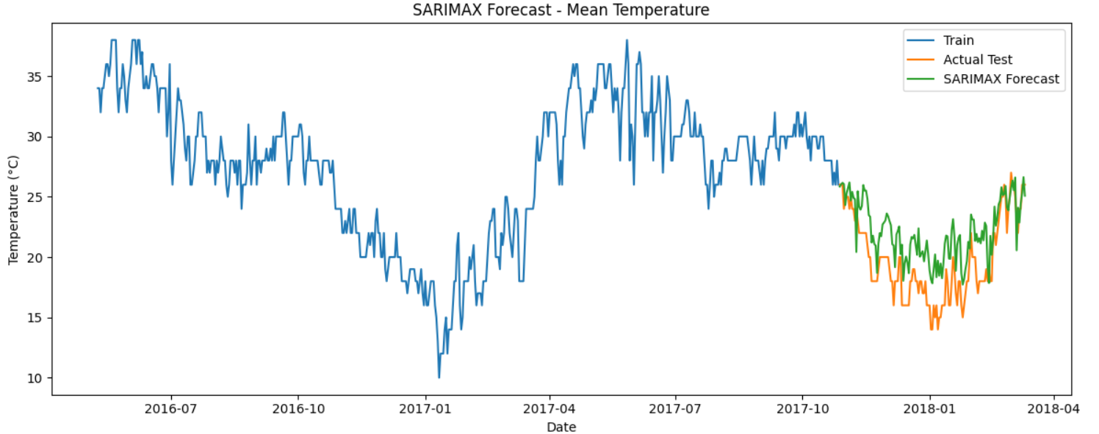
Residuals from SARIMAX were smaller and more random, showing that seasonal signals and weather-driven variations were captured more effectively. I did not use a full 365-day seasonal cycle because the dataset contains less than two years, making yearly seasonality unstable and unreliable. A monthly seasonal period (m=12) gives a far more robust and realistic fit for the available data.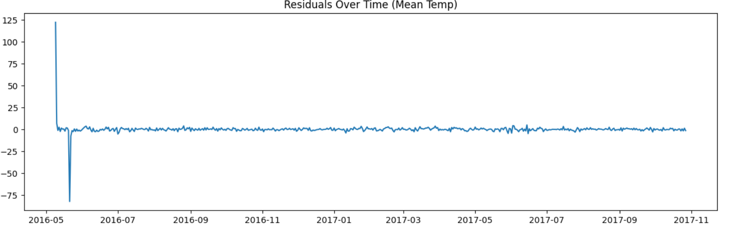

13. Comparison of Forecasting Models (ARIMA vs. SARIMAX)
Question: Which forecasting model demonstrates superior predictive performance, and what justifies this conclusion?
Focus Areas: MAE, accuracy score comparison, residual diagnostics, visual interpretation.
Answer:
Model | MAE | Accuracy
ARIMA (1,1,1) | ~7.4°C | ~63%
SARIMAX (1,1,1)(1,1,1,12) + exog + lags | ~2.6°C | ~87%
SARIMAX clearly demonstrated superior predictive performance compared to ARIMA. By incorporating monthly seasonality, weather-related exogenous variables (humidity, pressure, dew point, precipitation), and lag features, SARIMAX reduced the MAE to about 2.6°C and improved accuracy to ~87%. The model tracked the test data more closely, especially during gradual warming and cooling phases, and produced residuals that were smaller and less randomly distributed.
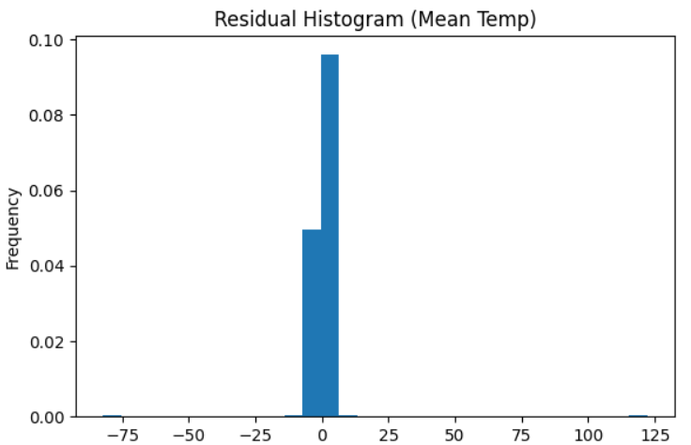
In contrast, the ARIMA(1,1,1) model achieved an MAE of ~7.4°C with an accuracy of only ~63%. It captured the overall trend but consistently missed sharper changes and seasonal movements, resulting in more spread and structured residuals and a forecast line that often lagged or overshot the true values. ARIMA therefore serves as a reasonable baseline, but SARIMAX offers substantially better accuracy, stability, and interpretability for daily temperature forecasting on this dataset.
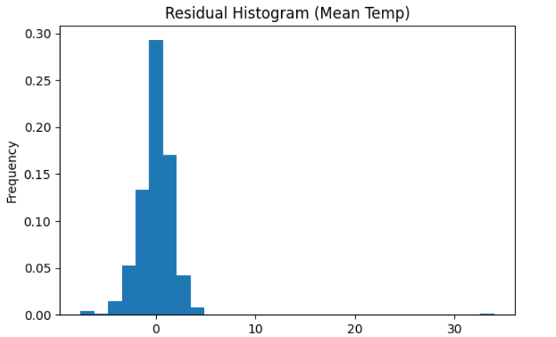

14. Insights and Recommendations
Question: What key insights have been derived from this clustering and forecasting analysis, and what practical recommendations can you offer?
Focus Areas: Comprehensive project insights, clustering and forecasting performance, practical implications, future improvements.
Answer:
The clustering analysis provided clear evidence of distinct weather regimes within the dataset. Both K-Means and Gaussian Mixture Models (GMM) consistently identified four meaningful clusters that correspond to hot–dry conditions, cooler dry periods, humid monsoon phases, and high-rainfall days. GMM offered smoother boundaries and better handled overlapping conditions, making it more appropriate for natural weather variability. In contrast, DBSCAN did not yield interpretable clusters due to the heterogeneous density of the data. These findings highlight that temperature, humidity, dew point, pressure, and precipitation jointly form coherent seasonal patterns that can be leveraged for downstream forecasting and monitoring applications.
The forecasting analysis demonstrated a substantial performance difference between ARIMA and SARIMAX. ARIMA captured only broad trends and showed higher error, indicating limited ability to account for seasonal effects or weather-driven fluctuations. SARIMAX, enhanced with monthly seasonality, lag features, and relevant meteorological variables, achieved markedly lower MAE and significantly improved accuracy. Its residuals were more randomly distributed, suggesting that the model appropriately captured the underlying structure of the temperature series.
Recommendations:
- Adopt SARIMAX (or similar exogenous-aware models) for operational forecasting, as it provides materially better predictive performance than ARIMA.
- Incorporate additional meteorological variables (e.g., wind speed, cloud cover, solar radiation) if available, to further strengthen predictive accuracy.
- Extend the dataset to multiple years to allow reliable modeling of annual seasonal components (m=365), which could enhance medium- and long-term forecasts.
- Prefer GMM for future clustering tasks, as it captures overlapping weather behaviors more effectively than density-based methods.
- Regularly retrain the forecasting model with the most recent data to maintain accuracy during seasonal transitions and extreme-weather periods.

